1- and Computer

1-

🌐 What Is a (In General)?
# Source: AI Source: Provided by: [Data Path: Persons Table -> ID Column: 1, Name_En Column: Motasem Essam] -> From: [ChatGPT] on [12/9/2025]
A —in general—is a system of interconnected components that can communicate, share resources, or exchange information with each other.

🧠 In simple terms:
# Source: AI Source: Provided by: [Data Path: Persons Table -> ID Column: 1, Name_En Column: Motasem Essam] -> From: [ChatGPT] on [12/9/2025]
A is a group of things connected together.

🔗 General Examples of s
# Source: AI Source: Provided by: [Data Path: Persons Table -> ID Column: 1, Name_En Column: Motasem Essam] -> From: [ChatGPT] on [12/9/2025]
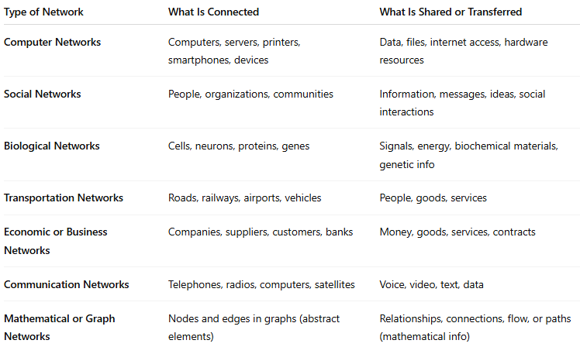
Type of | What Is Connected | What Is Shared or Transferred
Computer s | Computers, servers, printers, smartphones, devices | Data, files, internet access, hardware resources
Social s | People, organizations, communities | Information, messages, ideas, social interactions
Biological s | Cells, neurons, proteins, genes | Signals, energy, biochemical materials, genetic info
Transportation s | Roads, railways, airports, vehicles | People, goods, services
Economic or Business s | Companies, suppliers, customers, banks | Money, goods, services, contracts
Communication s | Telephones, radios, computers, satellites | Voice, video, text, data
Mathematical or Graph s | Nodes and edges in graphs (abstract elements) | Relationships, connections, flow, or paths (mathematical info)

1. Computer s
- Internet – the largest connecting millions of devices worldwide.
- Local Area (LAN) – computers connected within a home, school, or office.
- Wireless (Wi-Fi) – devices connected through radio signals.

2. Social s
- Friendship – people connected through personal relationships.
- Online social s – platforms like Facebook, Instagram, or LinkedIn.
- Professional – connections among colleagues and business partners.

3. Biological s
- Neural – neurons connected in the brain to process information.
- Food web – predator–prey relationships in an ecosystem.
- Genetic s – interactions between genes and proteins.

4. Transportation s
- Road s – highways and streets connecting cities.
- Railway s – train routes linking different regions.
- Airline route s – airports connected by flight paths.

5. Economic or Business s
- Supply chain – suppliers, manufacturers, distributors, and retailers.
- Trade s – countries connected through imports and exports.
- Corporate s – companies with shared interests or partnerships.

6. Communication s
- Telephone – landline or mobile connections for voice communication.
- Broadcast s – TV or radio stations distributing content.

7. Mathematical or Graph s
- Graph theory s – nodes and edges representing relationships.
- Electric power grid – generators, transformers, and consumers connected by cables.

🔧 Key Characteristics of a
# Source: AI Source: Provided by: [Data Path: Persons Table -> ID Column: 1, Name_En Column: Motasem Essam] -> From: [ChatGPT] on [12/9/2025]
- Nodes (the individual points, like computers or people)
- Links (connections between the nodes, like cables or relationships)
- Communication or interaction (how information moves between nodes)

📝 Summary
# Source: AI Source: Provided by: [Data Path: Persons Table -> ID Column: 1, Name_En Column: Motasem Essam] -> From: [ChatGPT] on [12/9/2025]
A is a system of connected elements that exchange or share something — whether in technology, biology, society, or infrastructure.

2-Computer

🌐 What Is a Computer ?
# Source: AI Source: Provided by: [Data Path: Persons Table -> ID Column: 1, Name_En Column: Motasem Essam] -> From: [ChatGPT] on [12/9/2025]
A computer is a system where two or more computers or devices are connected to share resources, exchange data, and communicate with each other. s can range from small setups in a home to vast global systems like the Internet.

🧠 In Simple Terms:
# Source: AI Source: Provided by: [Data Path: Persons Table -> ID Column: 1, Name_En Column: Motasem Essam] -> From: [ChatGPT] on [12/9/2025]
= Devices linked together to share data and resources.
These connections can be wired (Ethernet cables) or wireless (Wi-Fi, Bluetooth).

✅ Common Types of s:
# Source: AI Source: Provided by: [Data Path: Persons Table -> ID Column: 1, Name_En Column: Motasem Essam] -> From: [ChatGPT] on [12/9/2025]
- LAN (Local Area ): Covers a small area like a home, office, or school.
- WAN (Wide Area ): Covers large areas, cities, or countries; the Internet is the largest WAN.
- MAN (Metropolitan Area ): Spans a city or large campus.
- PAN (Personal Area ): Connects personal devices like smartphones, tablets, and laptops.
- CAN (Campus Area ): Links multiple LANs within a campus or business area.

🔧 What a Can Do:
# Source: AI Source: Provided by: [Data Path: Persons Table -> ID Column: 1, Name_En Column: Motasem Essam] -> From: [ChatGPT] on [12/9/2025]
- Share files and data easily between devices.
- Share hardware like printers and scanners.
- Access the internet collectively.
- Enable communication through emails, chats, or video calls.
- Support online gaming and streaming services.

✅ Key Purposes of Computer s:
# Source: AI Source: Provided by: [Data Path: Persons Table -> ID Column: 1, Name_En Column: Motasem Essam] -> From: [ChatGPT] on [12/9/2025]
- Resource Sharing: Reduce costs by sharing printers, storage, and software.
- Communication: Facilitate emails, messaging, and conferencing.
- Data Access: Allow multiple users to access the same data or applications.
- Centralized Management: Easier monitoring and management of devices.

📶 How It Works:
# Source: AI Source: Provided by: [Data Path: Persons Table -> ID Column: 1, Name_En Column: Motasem Essam] -> From: [ChatGPT] on [12/9/2025]
- Devices connect through physical cables (Ethernet) or wireless signals (Wi-Fi).
- Data is broken into small packets, sent over the , and reassembled at the destination.
- devices like routers and switches direct the data to the right location.

🔧 Basic Components:
# Source: AI Source: Provided by: [Data Path: Persons Table -> ID Column: 1, Name_En Column: Motasem Essam] -> From: [ChatGPT] on [12/9/2025]
- Computers/Devices: Endpoints like PCs, laptops, smartphones.
- Interface Cards (NICs): Allow devices to connect to the .
- Cables/Wireless Media: Physical wires (Ethernet) or Wi-Fi signals.
- Switches & Hubs: Connect multiple devices within a .
- Routers: Connect s and manage data traffic.
- Servers: Provide resources like files, emails, or web services.

Summary:
# Source: AI Source: Provided by: [Data Path: Persons Table -> ID Column: 1, Name_En Column: Motasem Essam] -> From: [ChatGPT] on [12/9/2025]
A computer links multiple devices to share resources, communicate, and access the internet. s can be small or global and use various devices and technologies to send data efficiently. They are essential for modern communication, business, education, and entertainment.

